Bahria University,

Karachi Campus



LAB EXPERIMENT NO.

___01___

LIST OF TASKS

|  |  |
| --- | --- |
| TASK NO | OBJECTIVE |
| **01** | **Install Linux on your Laptop and show the outputs.** |
| **02** | **By using the command line shell interface, practice the commands given in this lab. Write briefly about the usage of each command.** |
| **03** | **By using gedit, open a text editor and write the C program That print your name. Save the written file as “name.c”. In order to compile and execute the output file, do the following:**   * **$ gcc - o name name.c** * **$ ./name** |
| 04 | Make changes within the above program to display a new output text as given below. Write down the developed program.   * Hello World! I am studying Operating Systems. * My name is “Enter your name”. * My registration number is “Enter your registration number”. * I belong to Bahria University Karachi Campus. |

Submitted On:

02-03-2023

(Date: DD/MM/YY)

**Task 01:** Install Linux on your Laptop and show the outputs.

**Output:**

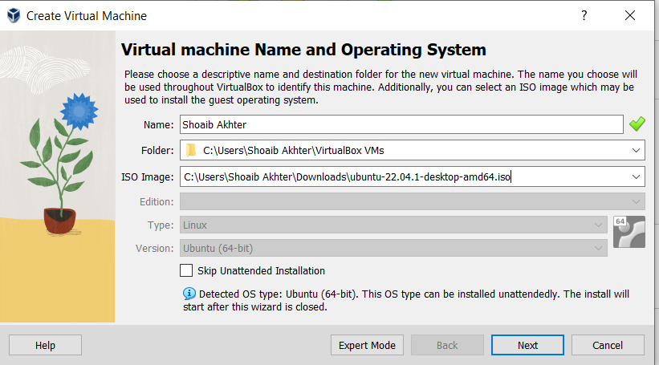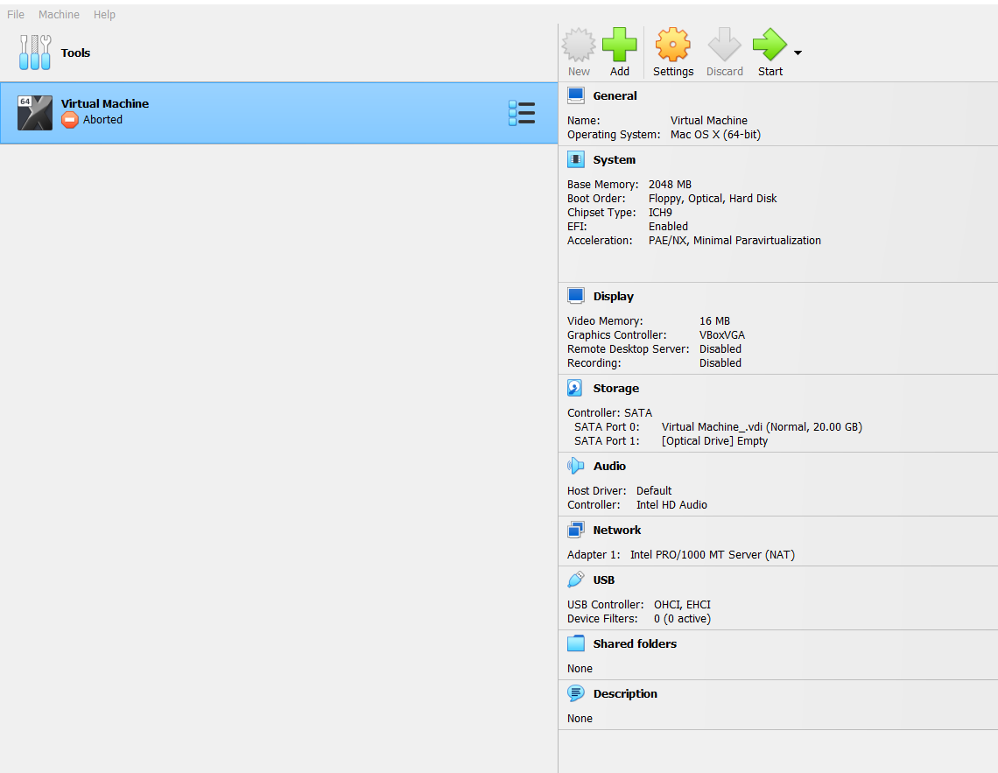

**Task 02:** By using the command line shell interface, practice the commands given in this lab. Write briefly about the usage of each command.

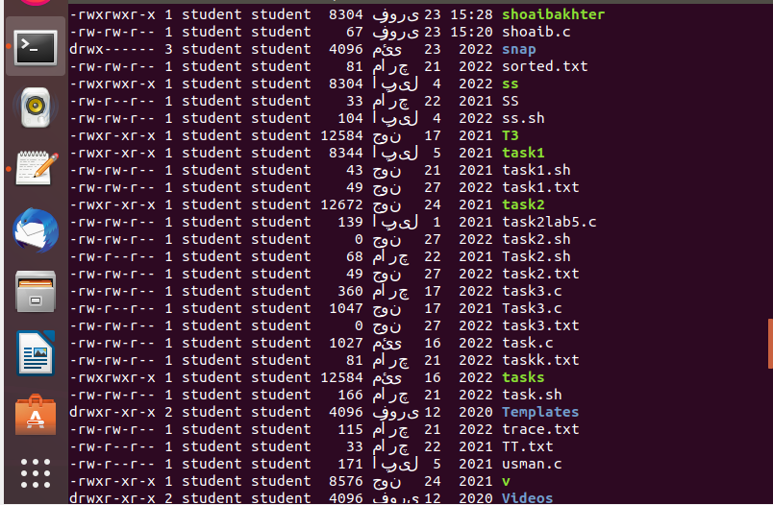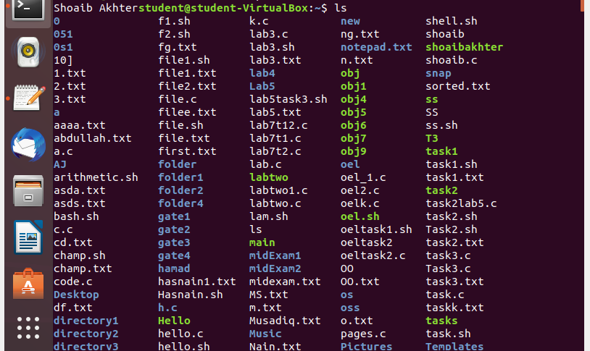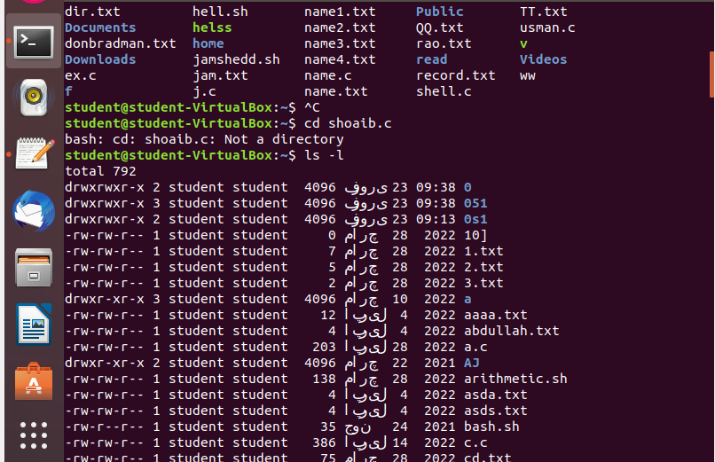**Output:**

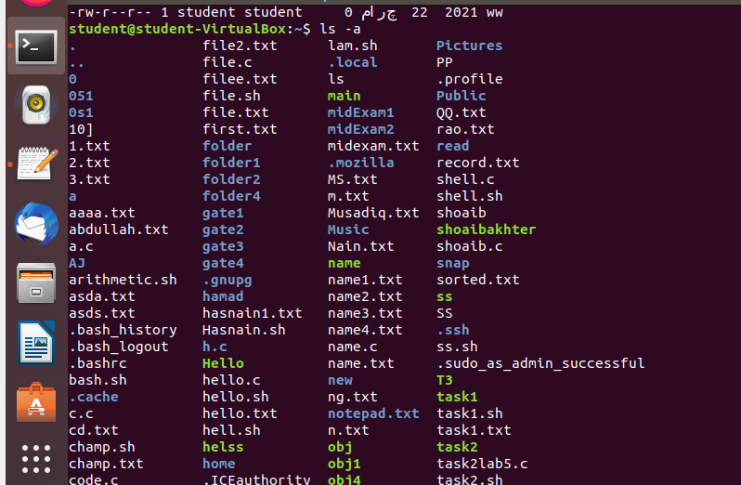

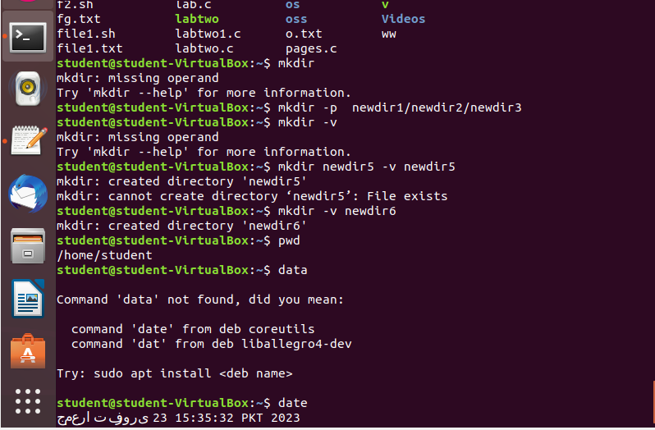

**Task 03:** By using gedit, open a text editor and write the C program That print your name. Save the written file as “name.c”. In order to compile and execute the output file, do the following:

* $ gcc - o name name.c
* $ ./name

**Source Code:**

**Output:**

**Task 04:** Make changes within the above program to display a new output text as given below. Write down the developed program.

* Hello World! I am studying Operating Systems.
* My name is “Enter your name”.
* My registration number is “Enter your registration number”.
* I belong to Bahria University Karachi Campus.

**Solution:**

**Output:**

